**Background**

**Dieselisation**

Since the turn of the millennium, the car fleet registered across many European Nations has gradually undergone a process of dieselisation, whereby cars with diesel engines have become more popular amongst drivers and, in some places (such as the Republic of Ireland), have displaced petrol as the main fuel type.

**Spatial Arbitrage**

Countries often employ fiscal measures to manage the demand for a good and raise taxation revenue for its sale. In certain situations, neighbouring countries may follow quite different fiscal strategies, which leads to disparities in the sale price faced by consumers in the different countries. If the good in question is homogenous (i.e. its qualities does not differ between countries), this could generate a spatial arbitrage opportunity. Under such an opportunity, consumers of a good in a nation which has a higher sales price may be able reduce the costs they face by travelling to the neighbouring country where the sales price is lower to make their purchase. Spatial arbitrage opportunities have been extensively evaluate for such goods as tobacco and alcohol (Leal et al. 2010). The phenomenon also extends to the transport sector, where the price of fuel faced by consumers in neighbouring countries can be sufficiently different to induce what is often referred to as fuel-tourism or fuel-fetching behaviour (Rietveld and van Woudenberg, 2005). Such behaviour can generate a number of adverse consequences, leading to reductions in tax and fuel station revenue in the country with the higher price level as well as increasing car travel.

In an initial empirical investigation of fuel-tourism, Rietveld et al. (2001) examined the consequences of cheaper fuel being available across the border in Germany and Belgium on the sale of gasoline in the Netherlands. Their findings indicate that the average Netherlands driver would be willing to travel 1 km to a cheaper fuel station for every 1 cent difference in the price of fuel. From this finding, Rietveld et al. (.ibid) recommend that the Netherlands should introduce graduated fiscal measures, whereby the tax rate applied to fuel diminishes as nearness to the border increases. Implementing this recommendation would bring the gasoline prices in the border region of the Netherlands into line with those present across the border in Germany and Belgium, thus removing the incentive for fuel-tourism. However, such a strategy could lead to fuel stations outside of the border region (i.e. inland) seeing reductions in their revenues if inland Dutch drivers take advantage of the reduced gasoline price when they travel to the border region. The reverse situation was in effect during the latter part of the twentieth century in Switzerland, whereby the Swiss price of gasoline was substantially lower than that in the neighbouring countries of France, Italy, and Germany. Banfi et al. (2005) examined whether this price differential motivated fuel-tourism into Switzerland between 1985 and 1997 though an econometric assessment of gasoline sales within a 5 kilometre vicinity of the border. Their assessment indicates that changes to the Swiss price of gasoline, the neighbouring country price of gasoline, Swiss income per capita, and neighbouring income per capita all affect the quantity of gasoline sold. Through a counter-factual simulation of a scenario where the fuel price between Switzerland and neighbouring countries did not exist, Banfi et al. (ibid.) estimate that 9% of gasoline sales in the Swiss border region can be attributed to fuel-tourism during the study period.

While price disparities in fuel prices are often visible between different countries, there are also examples where they exist between regions of the same country. A case in point is Spain, which since 2002 has operated a Hydrocarbons Retail Sales Tax that allows the autonomous communities of Spain to apply a regionally specific levy on fuel sales. This ability has contributed to the price of diesel to varying between the autonomous communities by up to 3.4 cents per litre. Leal et al. (2009) evaluated whether this situation affected demand for diesel in Aragon (one of the communities with the lowest diesel price) between 2001 and 2007 and found that an increase in the price of diesel in Catalonia (a neighbouring community to Aragon) increased the demand for diesel in Aragon by 1.6%. Romero-Jordán et al. (2013) consider if the occurrence of this regional fuel levy affected price setting behaviour of fuel stations in the vicinity of the border between regions with alternative levies. Their analysis indicates that fuel stations on the side of the border with the higher level set a lower price for diesel compared to that inland, implying that they do not fully pass on the fuel levy onto customers in order to discourage fuel-tourism.

**The Situation in Northern Ireland**

Northern Ireland represents the only nation of the United Kingdom that has a land border with another country, being the Republic of Ireland to the south and west. Since 1923, a Common Travel Area has been in effect between the United Kingdom and the Republic of Ireland, following an open border policy subject to minimal control which allows for the unrestricted movement of individuals between the two countries.

The fiscal measures on transport fuel in effect in Northern Ireland follow the policy set out by the UK Government. This covers the application of a set fuel duty of 57.95 pence per litre for both petrol and diesel as well as a 20% value added tax to the sale price. A different set of fiscal measures is in effect in the Republic of Ireland ……

Due to the divergent fiscal measures in effect between Northern Ireland and the Republic of Ireland, a substantial price difference is apparent for diesel fuel. Figure Y displays the average diesel fuel price between 2000 and 2016 for Northern Ireland and the Republic of Ireland, with the price difference persevering throughout this time period. At its most divergent (in 2002), the differential in fuel price between the two countries was 31 pence per litre, with an average difference of 20 pence per litre during this time period. Due to the persistence of this price differential, the possibility exists for it not only to have generated fuel-tourism but to also have motivated a higher rate of diesel car ownership in Northern Ireland due to the availability of cheaper fuel in the border region.

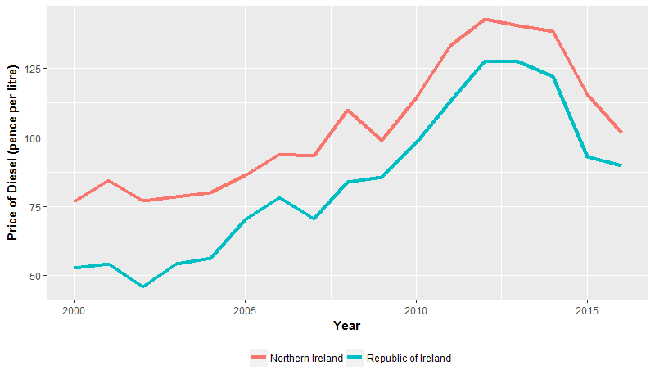

**Figure Y:** Average price of diesel road transport fuel in Northern Ireland and the Republic of Ireland (Automobile Association, 2016)

In parallel to the fuel price difference between Northern Ireland and the Republic of Ireland generating fuel-tourism across the border, another set of issues are at play that could be affecting the rate of diesel car ownership. The smuggling of cheaper fuel from the Republic of Ireland into Northern Ireland by organised crime is a known issue (House of Commmons, 2012). In addition, fuel laundering operations, which take rebated diesel (i.e. diesel sold not for use on roads and not subjected to fuel duty, referred to as ‘red diesel’ in the UK) and remove the marker dyes, have a relatively high occurrence in Northern Ireland. These two issues lead to a situation whereby around 12% of the diesel sold for road transport in Northern Ireland is estimated to be illicit (House of Commons, 2012). It is possible that these two issues will concentrate in the border region due to the relatively high level of rurality, thus the availability of cheaper diesel at the border is likely being promoted by these issues.